
May monthly report
Project Title:
Conversion of post-combustion gas from cement manufacturing to syngas by electrochemical CO₂ capture and reduction
……..........................................................
Dr. Pongkarn Chakthranont
Sothearoth Heng
NCR ID: 803198
Under the supervision of
Dr. Pongkarn Chakthranont
Contract Number: NCR-NN-2023-20170-EN
May 2024

- Tasks list for April
- CO2RR performance test of varied Ni-2D-NC mass loadings under higher applied current densities with a cell config. of IrO₂/AEM/Ni-2D-NC.
- Investigation of CO₂ partial pressure (15, 30, 50, and 100%) under 200mA/cm² and
- Fabrication and electrocatalytic studies of deposited IrO₂-TiPt based anode catalyst.

- Experimental Procedure
Fabrication of IrO_{x}/TiPt-felt electrode
The IrO_{x}/TiPt-felt anode electrode was prepared via thermal deposition method as following step by step:
Etching process
- Sonically washing TiPt felt with DI water and acetone.
- Etching Ti/Pt felt in 10ml of 6M HCl at 90°C for 45 min.
- Weighing 3x3 cm² TiPt felt.
Preparation of dip coating solution
- 30 mg of IrCl₆.xH₂O was added into 10mL of IPA with 10% v/v HCl.
Dipping process
- 3x3 cm² TiPt felt was dipped into the dip coating solution for 5 min.
- The dipped TiPt felt was then dried at 100C for 10min in oven and followed by calcination at 500C for 10min in muffle furnace.
- After that, the calcined TiPt felt was cooled down and weighed.
- Repeat step 5-7 for several times until obtaining desired mass loading.
Remark: IrO_{x} mass loading can be raised by either increasing concentration of dip coating solution or dipping process.

Preparation of the Ni-2D-NC cathode electrode via spray coating method
The as-prepared Ni-2D-NC catalyst was spray-coated onto Sigracet 39BB carbon paper. Briefly, 50 mg of the Ni-2D-NC and 127µL or 10% by catalyst weight of XA-9 binder were ultrasonically mixed with 10ml of IPA for 60 min to form a dark colloidal solution which was then sprayed onto Sigracet 39BB carbon paper with 0.5 ml/min on 95 °C hotplate to obtain ~ 0.6 ± 0.1 mg/cm². To obtain 1.2 and 1.8 ± 0.1 mg/cm², 100 and 150 mg of Ni-2D-NC catalyst was added into the solution.

Electrochemical CO2RR measurements
A 5 cm² MEA electrolyzer was used to evaluate the CO2RR performance under modulated operating conditions. The Ni foam, AEM (X37-50 Grade RT, Dioxide Materials), and Ni-2D-NC cathode catalyst were employed as the anode, membrane, and cathode electrode, respectively. 50 ml of 0.5M KOH was recirculated and used throughout the experiment as the anolyte at 8 ml/min. Various CO₂ partial pressures (0.15, 0.3, 0.5, and 1.0) was introduced into the cathodic inlet under CO₂ flow rates of 15, 30, 50, and 100 ml/min (balancing by N₂ gas), respectively. The cathodic outlet was directly injected into an online gas-chromatography for gas products analysis.

- Results
Influence of Ni-2D-NC mass loading on CO2RR performance under higher current densities
To solidify the impact of catalyst mass loading (m/l), we performed CO2RR using a Ni-2D-NC cathode catalyst with loadings of 0.6 and 1.2 mg/cm² across an applied current density range of 200 to 400 mA/cm². As shown in Fig. 1, at 200 to 300 mA/cm², the m/l of Ni-2D-NC had minimal influence on CO2RR performance, with FE(CO) remaining above 90%. However, a significant effect of catalyst m/l was observed at higher applied current densities. Increasing the current density from 300 to 350 mA/cm² caused the FE(CO) for 0.6 and 1.2 mg/cm² to abruptly drop to 76% and 82%, respectively. Further increasing the current density to 400 mA/cm² drastically decreased FE(CO) to around 28%, as HER effectively outcompeted CO2RR.

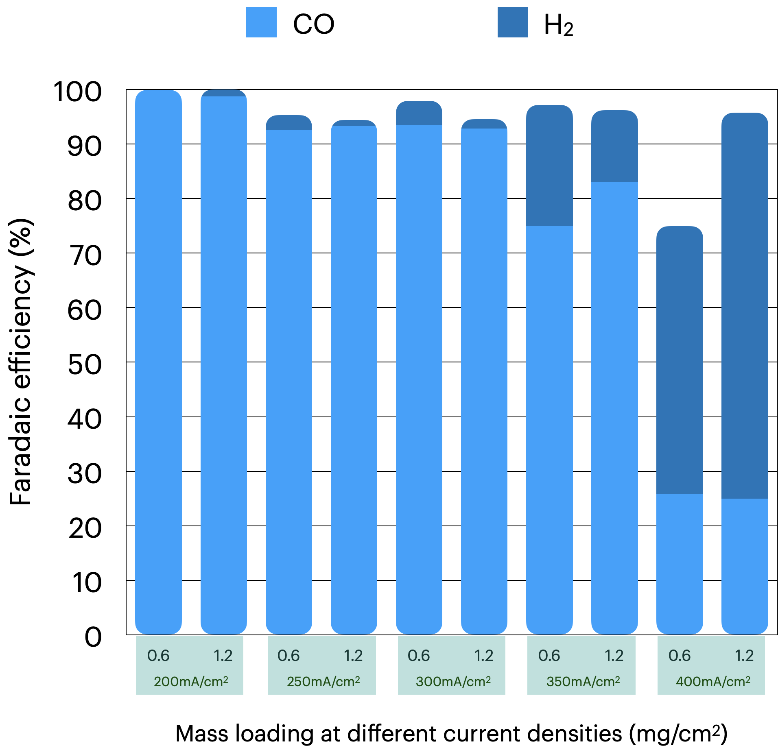
Figure 1. Faradaic efficiency of CO and H₂ of Ni-2D-NC catalyst with m/l of 0.6 and 1.2 mg/cm² under various applied current densities.

CO2RR performance of Ni-2D-NC cathode electrode under various catalyst mass loadings (m/l) and CO₂ partial pressures (PCO₂)
To identify the factors determining the CO2RR performance of the Ni-2D-NC cathode catalyst at different CO₂/N₂ mixture concentrations, we applied various CO₂ partial pressures of 0.15, 0.3, 0.5, and 1.0 at a constant total flow rate of 100 ml/min and an applied current density of 200 mA/cm². Regardless of the catalyst m/l, the CO2RR performance of Ni-2D-NC, whose FE(CO) marginally increased with increasing P(CO₂), was strongly impacted by CO₂ concentration.

To exclude the possibility that the poor performance of the Ni-2D-NC catalyst at low P(CO₂) resulted from electrode optimization, various Ni-2D-NC mass loadings (0.6, 1.2, and 1.8 mg/cm²) were prepared and tested. At P (CO₂) of 0.15 (15% CO₂/85% N₂ mixture), the FE(CO) of the Ni_{1.2-1.8}-2D-NC catalyst was slightly higher than that of Ni0.6-2D-NC. Interestingly, we observed a remarkable increase in FE(CO) of Ni_{1.2-1.8}-2D-NC at higher P (CO₂) compared to Ni_{0.6}-2D-NC, implying the importance of catalyst loading amount on CO2RR performance.

Additionally, the pulse electrochemical method was applied to study the improvement of Ni-2D-NC performance under a diluted 15% CO₂ condition to see if this could mitigate salt buildup and competitive HER. Preliminary results of pulse electrolysis under operation and regeneration potentials of 2.8V and 0V exhibited a substantial increase in FE(CO) to almost 80% with the Ni_{1.2}-2D-NC catalyst. Further verification of the pulse electrolysis operation is needed.
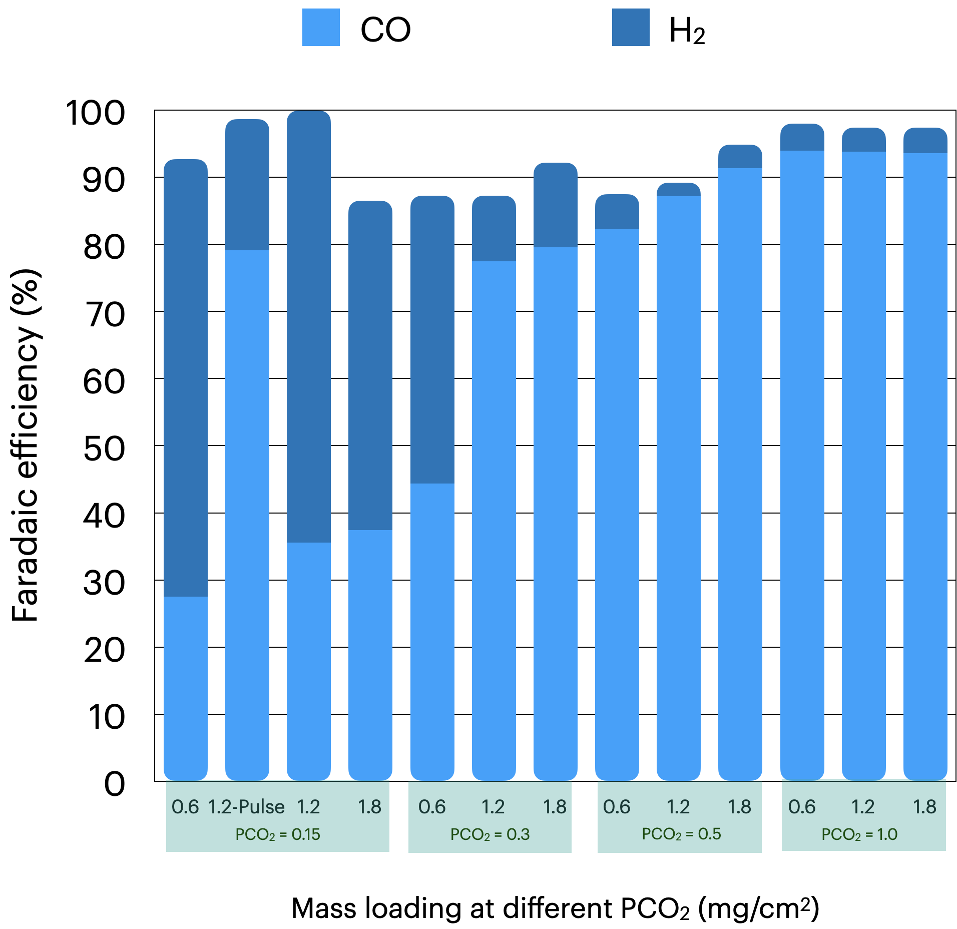
Figure 2. Faradaic efficiency of CO and H₂ of Ni-2D-NC cathode catalyst under different m/l (0.6 – 1.8 mg/cm²) and PCO₂ (0.15 -1.0) at 200mA/cm².

Studies of the possibility of using deposited IrO_{x} on TiPt felt as an anode
The IrO_{x}/TiPt-felt anode was prepared using different deposition methods (electrodeposition and thermal deposition) and varying loading amounts of IrO_{x}. Cyclic voltammetry (CV) profiles of the samples indicated that the presence of IrO_{x} on the TiPt felt enhanced the electrode's catalytic activity. IrO_{x}/TiPt-felt samples prepared by thermal deposition outperformed the others, with the thermal-deposited IrO_{x}/TiPt-felt having an IrOx m/l of 0.85 mg/cm² exhibiting the highest catalytic activity. Subsequently, thermal-deposited IrO_{x}/TiPt-felt samples with m/l values of 0.5 and 0.85 mg/cm² were deployed as the anode for CO₂ reduction reaction (CO2RR) performance testing. This was done in conjunction with a Ni_{1.2}-2D-NC cathode, under pure CO₂, in a 0.1M KHCO₃ electrolyte, and at a current density of 200 mA/cm². Chronopotentiometry (CP) profiles (Figure 3) illustrated that a higher IrO_{x} m/l anode electrode (0.85 mg/cm₂) performed CO2RR at a notably lower cell potential of ~3.4V compared to a lower m/l anode (~4.3V). Based on the CV profiles, it is worth noting that the IrO_{x}/TiPt-felt with an m/l of 1.5 mg/cm² was assumed to share similar results with the 0.5 mg/cm² sample.

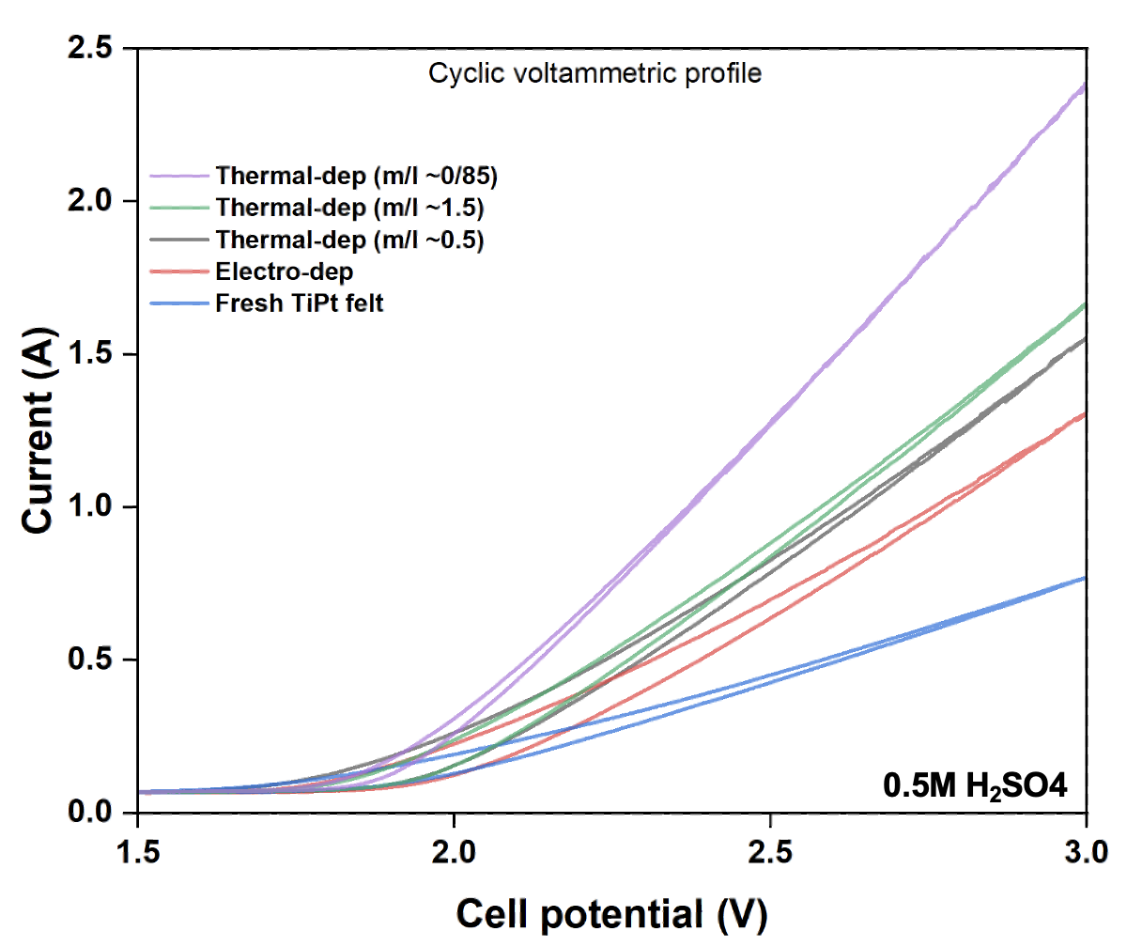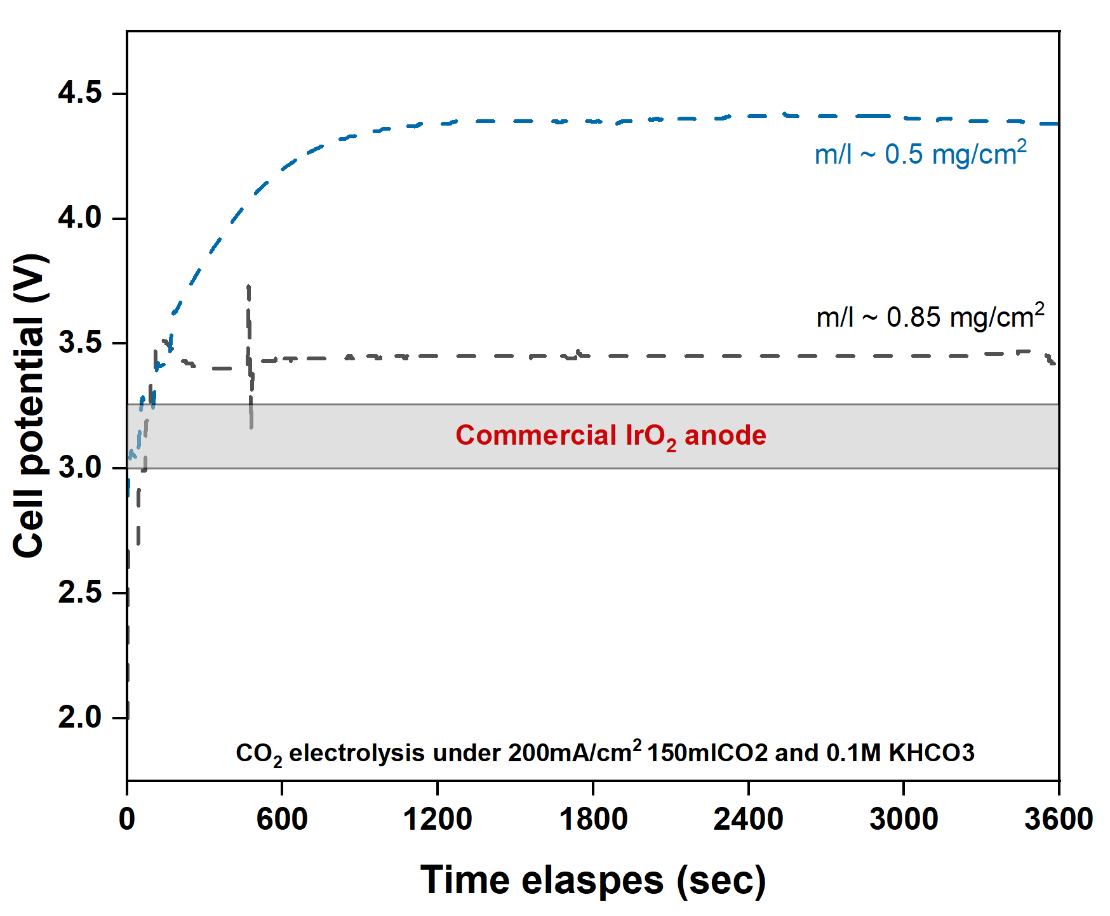
Figure 3. CV and CP profiles of various IrO_{x}/TiPt-felt samples.

- Summary
In summary, for the Ni-2D-NC cathode, higher mass loadings were found to be beneficial at high current densities and low CO₂ concentrations. At 350 mA/cm², FE(CO) dropped to 76% and 82% for 0.6 and 1.2 mg/cm² loadings, respectively, and further decreased to around 28% at 400 mA/cm². At higher CO₂ partial pressures, the FE(CO) for Ni1.2-1.8-2D-NC significantly increased compared to Ni0.6-2D-NC, underscoring the importance of catalyst loading. Under diluted 15% CO₂ conditions, applying a pulse electrochemical method significantly improved the CO2RR performance of Ni_{1.2}-2D-NC with nearly 80% of FE(CO), indicating substantial mitigation of salt formation and competitive HER. CV and CP profiles demonstrated that a thermal-deposited IrO_{x}/TiPt-felt with an m/l of 0.85mg/cm² exhibited the highest catalytic activity at a significantly lower cell potential.

- Upcoming tasks
- Improvement of CO2RR performance of Ni_{1.8mgcm-2}-2D-NC catalyst under PCO₂ of 0.15 using pulse electrochemical method:
  - Influence of operation and regeneration times
  - Influence of applied pulse potential
- Investigation of CO2RR performance of additional 5mg/cm² CALF20 on the GDE as a surface-accessible CO₂ layer under a diluted CO2 condition (PCO₂ of 0.15).

